**import** java.io.FileNotFoundException;

**import** java.io.IOException;

**import** java.io.PrintWriter;

**public** **class** forecast {

**private** **double** temp = 72;

**private** String sky = "clear";

**private** **int** chance = 0;

**public** forecast() {

}

**public** forecast(**double** T, String condition, **int** percent ) {

T = temp;

condition = sky;

percent = chance;

}

**public** **void** printToFile(**double** temp, String sky, **int** chance) {

PrintWriter p = **null**;

**try** {

p = **new** PrintWriter("forecast1111.txt");

p.println("The temperature is " + temp + "." );

p.println("The sky condition is " + sky + ".");

p.println("The chance of rain is " + chance + ".");

p.close();

}**catch**(FileNotFoundException f) {

System.***out***.print("There was a file not found error.");

f.printStackTrace();

}**catch**(IOException i) {

System.***out***.println("There is an IO error");

}

**catch**(Exception e) {

System.***out***.println("There is an error");

}

}

**public** **double** getTemp() {

**return** temp;

}

**public** **void** setTemp(**double** temp) {

**if**(temp > -100.0 && temp < 150.0 ) {

**this**.temp = temp;

}

**else**

**this**.temp = 72;

}

**public** String getSky() {

**return** sky;

}

**public** **void** setSky(String sky) {

**if**(sky == "" || sky==**null**) {

**this**.sky = "clear";

}

**else**

**this**.sky = sky;

}

**public** **int** getChance() {

**return** chance;

}

**public** **void** setChance(**int** chance) {

**if**(chance > 0 && chance < 100) {

**this**.chance = chance;

}

**else**

**this**.chance = 0;

}

**public** **double** FtoC(**double** T){

**return** (T - 32)* (5.0/9);

}

**public** **double** CtoF(**double** T){

**double** f = (T * (9.0/5)) +32;

**return** f;

}

**public** **double** FtoK(**double** T){

**double** K = (T - 32) * (5.0/9) + 273.15;

**return** K;

}

**public** **double** KtoF(**double** T){

**double** f = (T - 273.15) * (9.0/5) + 32;

**return** f;

}

**public** **boolean** rain(**int** chance ) {

**if**(chance > 46) {

**return** **true**;

}

**else**

**return** **false**;

}

}

MAIN CLASS

**import** java.util.Scanner;

**public** **class** MainForecast {

**public** **static** **void** main(String[] args) {

Scanner scan = **new** Scanner(System.***in***);

System.***out***.println("Enter the temperature in F: ");

**double** T = scan.nextDouble();

System.***out***.println("Enter the sky condition: ");

String condition = scan.next();

System.***out***.println("Enter the chance of rain: ");

**int** percent = scan.nextInt();

forecast inputs = **new** forecast(T, condition, percent);

inputs.setTemp(T);

inputs.setSky(condition);

inputs.setChance(percent);

System.***out***.println("You entered: " + inputs.getTemp());

System.***out***.printf("The temperature from F to C is %3.2f C\n", inputs.FtoC(T));

System.***out***.printf("The temperature from F to K is %3.2f K\n", inputs.FtoK(T));

System.***out***.printf("The temperature from K to F is %3.2f F\n", inputs.KtoF(inputs.FtoK(T)));

System.***out***.printf("The temperature from C to F is %3.2f F\n", inputs.CtoF(inputs.FtoC(T)));

**if**(inputs.rain(percent) == **true**) {

System.***out***.println("It is going to rain");

}

**else**

System.***out***.println("It will not rain");

inputs.getChance();

inputs.getSky();

inputs.printToFile(T, condition, percent);

}

}

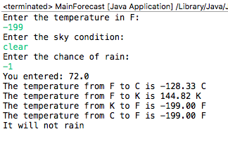

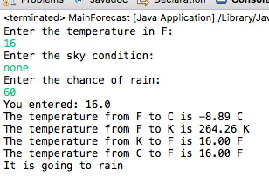

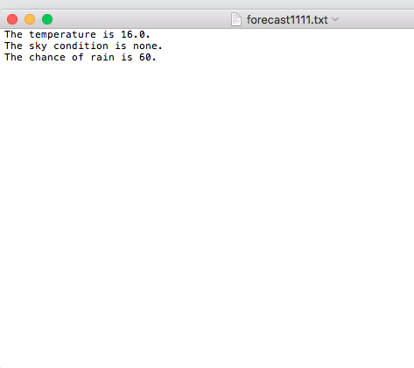

There are many differences that separate an object from a class. An object is an instance of the class, in a class objects can be created. This usually happens when using the new keyword for example in my code I used forecast inputs = new forecast(); Also a class is laid out like an template to follow. In my code I had to first declare the class in order to create objects to be a part of it.

After doing some research I found that there are many ways to create objects, while only one way to create a class. On javapoint they describe a Class: Human Object : Male and Female. A class is logical, while the objects are physical.